SOT143
SOT323
603
805
805
805+
805
Capacitors
Resistor
Inductor
Transistor & Diodes

All parts can be found through a combination of: part type (cap, res, BJT, etc)., color marked on package, package type and qty of parts in kit.
See design document for part placement, including pin orientation where applicable.
Item | Color | Qty | Package
100 Ohms  (805 SMD)  (Digikey P100CCT-ND) | Orange/ Red | 2 | 805 | 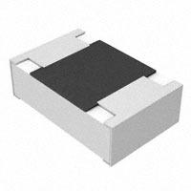
75k Ohms  (805 SMD)  (Digikey P75.0KCCT-ND) | Purple | 2 | 805
50 Ohms  (805 SMD)  (Digikey P49.9CCT-ND) | Red | 4 | 805
200 pF  (805 SMD)  (Digikey 490-10741-1-ND) | Green | 4 | 805 | 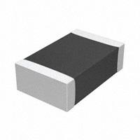
.1uF  (805 SMD)  (Digikey 587-1133-1-ND) | Blue | 3 | 805+ | 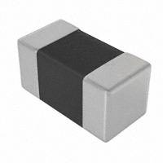
100nH  (805 SMD – wirewound)  (Digkey A103758CT-ND) | Clear | 2 | 805 | 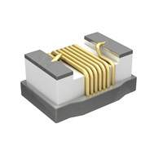
1.5k Ohms  (805 SMD)  (Digkey P1.50KCCT-ND) |  | 2 | 805
2.7k Ohms  (805 SMD)  (Digkey 2.7KACT-ND) |  | 2 | 805
220 Ohms  (805 SMD)  (Digkey P220ACT-ND) |  | 2 | 805
1 pF  (603 SMD)  (Digikey 709-1199-1-ND) |  | 2 | 603
3 pF  (603 SMD)  (Digikey 712-1347-1-ND) |  | 2 | 603
Diode  (HSMS-2829-BLKG)  (Mouser 630-HSMS-2829-BLKG) | Black package w/blue tape | 2 | SOT143  “C9” Mark
BJT – 9 GHz  (BFU550R)  (Digikey 568-11515-1-ND) | Black package | 2 | SOT143  “WTC”  Mark
Balun  (Minicircuits TCM4-14+ ) | Black Package | 4 | 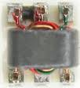
2in x2in PCB 1 oz. single sided  double sided (MG Datasheet)(Digikey 473-1006-ND) |  | 2 | 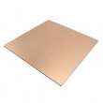
Mixer pre-fabbed PCB  (Obtain from rickettslab.org or instructor) |  | 2  ($2)
Power Amplifier pre-fabbed PCB  (obtain from rickettslab.org or instructor) |  | 1  ($2)
½ SMA cable (connector and open end) |  | 1 | 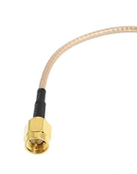
SMA connector  (Digikey J502-ND Dimensions or equivalent) |  | 15 | 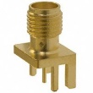
9V Battery connector |  | 1 | 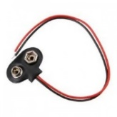
SMA-SMA connectors (for assembling radio) |  | 5  (provided) | 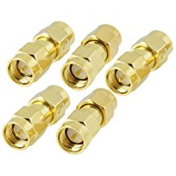
12x12 Venture Copper Foil Sheet Adhesive  (ebay or other retailer) |  | 2  Sheets | 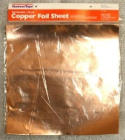
Foil tape |  | 30 cm | 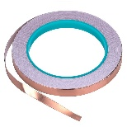
12” x 12” White corrugated plastic sheet (4-8 mm, thickness not important)  Example from Amazon. |  | 1
9V Battery |  | 1 | 